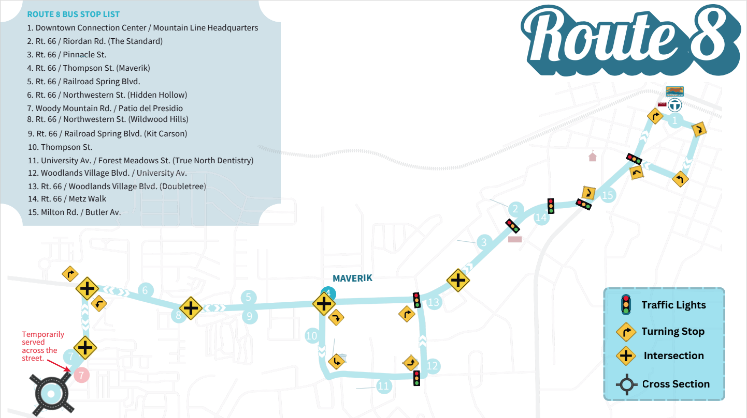
Route 8 - 29153

The case assigned to us is to create a model that identifies routes with a high number of stops that do not match the defined stop waypoints provided in the dataset. Additionally, the case requires identifying routes with high deadhead hours, where deadhead refers to any time or mileage not generating revenue, typically occurring between the Mountain Line Operations Facility at 3773 N. Kaspar Dr. and the first or last stop on a route.
For this analysis, we selected Route 8 as our focus. Since Route 8 begins from downtown, we decided not to analyze deadhead hours, as Mountain Line was specifically interested in deadhead activity between the operations facility and downtown. This decision was made after consulting with Mountain Line stakeholders.
To address the objective of identifying stops that do not align with defined stop waypoints, we focused on passenger data, as stop activity is directly influenced by passenger demand. Based on this approach, we conducted multiple analyses including:
- Passenger Demand Analysis
- Peak Time Analysis
- Route Optimization Analysis
- Stop-Level Demand Analysis (Geo Pandas with Python)
- Trend Analysis of Stops and Passenger Flow
- Identification of Unknown or Undefined Locations
These analyses were presented to Mountain Line, Professor Yichang, and Professor Kristin, and we received valuable feedback. Approximately 95% of the results were validated and aligned with expectations, demonstrating the effectiveness of our analytical approach.
PREDICTION MODEL DESCRIPTION
As our analysis is focused on passenger behavior, the objective of the predictive model is to estimate the number of passengers boarding and alighting based on stop activity and temporal patterns such as arrival date.
The dataset contains data for two months, November and December. To build the predictive model, we used November data as the training dataset. This allowed the model to learn underlying patterns in passenger flow, including variations across days of the week and different periods within the month.
We then applied the trained model to December data as a test dataset. Since actual December data is available, this enables us to directly compare predicted values with real passenger counts and evaluate the accuracy of the model.
This approach helps validate how well the model generalizes to unseen data and provides insights into its effectiveness in forecasting passenger demand for future periods.

STEP-BY-STEP PROCESS OF PREDICTIVE MODEL (RAPIDMINER)
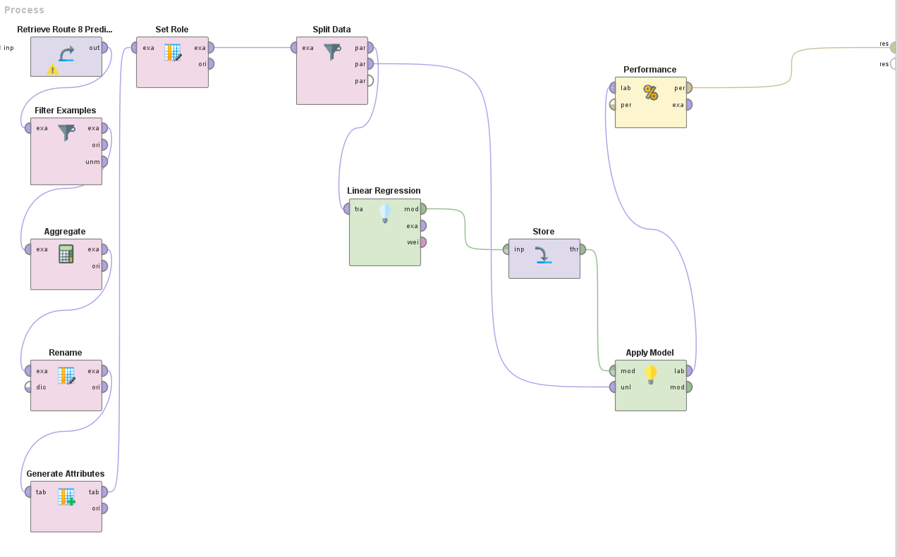
STEP 1: DATA RETRIEVAL
The process begins by importing the dataset into RapidMiner using the Retrieve operator. This dataset contains passenger information including stop names, arrival dates, and passenger counts for November and December.

STEP 2: FILTERING NOVEMBER DATA (TRAINING DATA)
To build the prediction model, only November data was selected using the Filter Examples operator.
Condition used:
- arrived_date ≥ 11/01/2025
- arrived_date ≤ 11/30/2025
This ensures that the model is trained only on historical data.
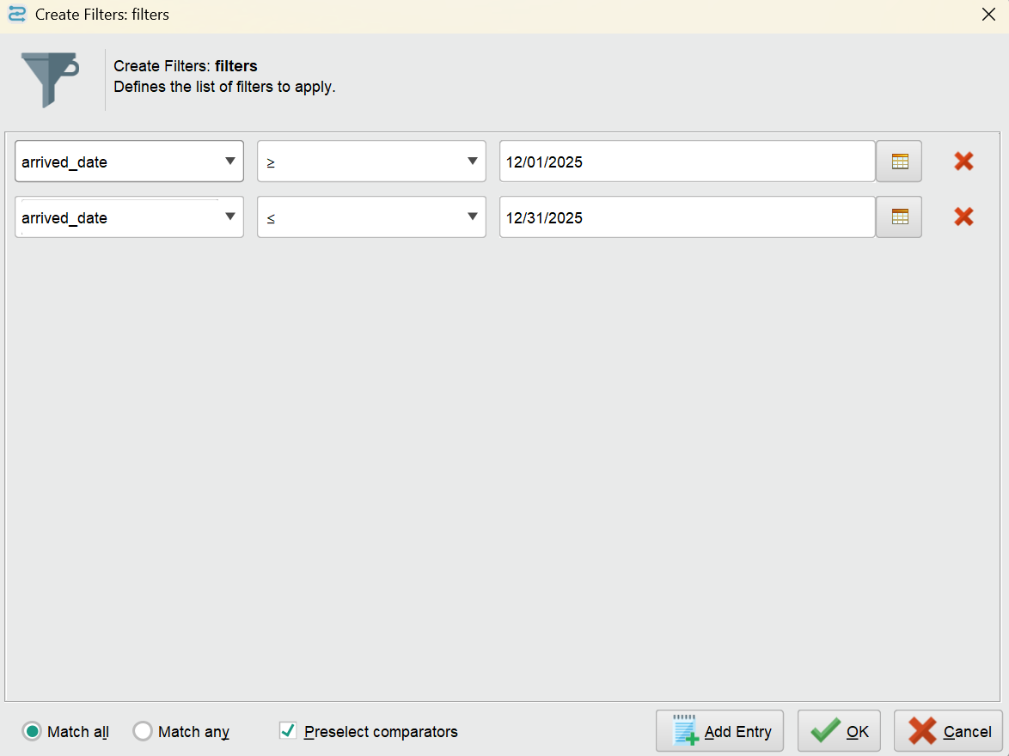
STEP 3: DATA AGGREGATION
Since the data is at stop-level, it was aggregated to obtain daily passenger totals.
Using the Aggregate operator:
- passengers_on → sum
- passengers_off → sum
- Grouped by: arrived_date
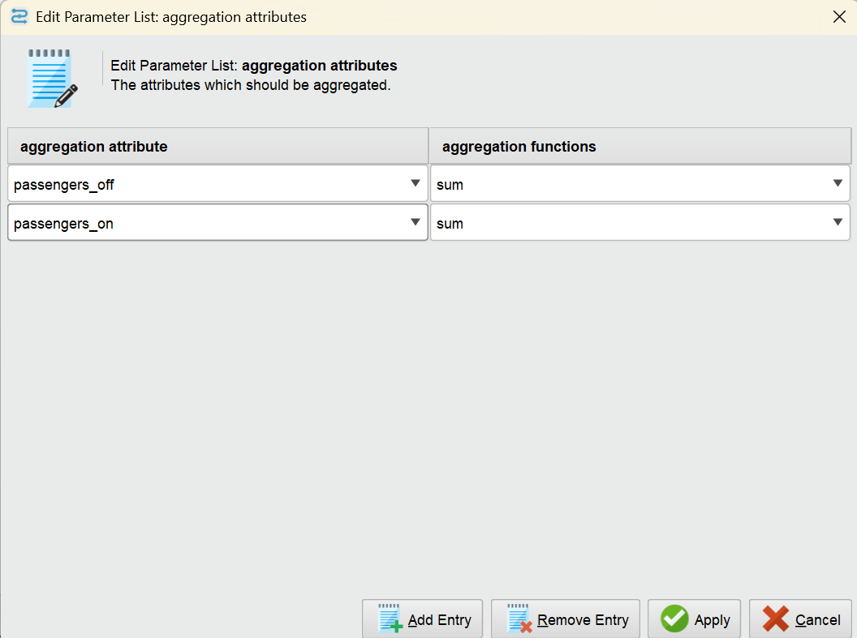
This converts multiple rows per day into a single row per day.

STEP 4: RENAMING ATTRIBUTES
The aggregated columns were renamed for clarity using the Rename operator:
- sum(passengers_on) → total_on
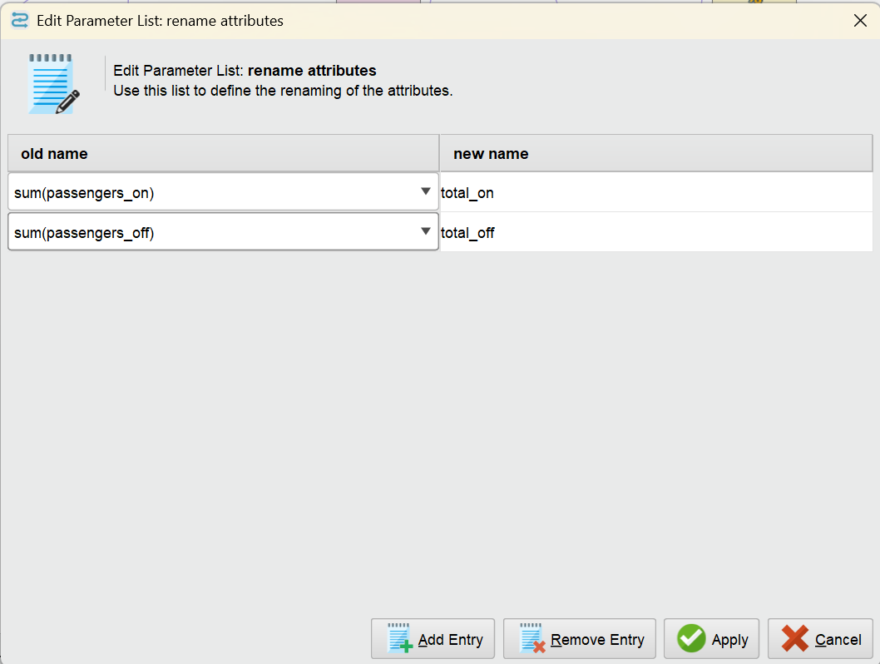
- sum(passengers_off) → total_off

STEP 5: FEATURE ENGINEERING
New features were created using the Generate Attributes operator to help the model learn time-based patterns:
- day_of_week → extracted from arrived_date
- day_of_month → extracted from arrived_date
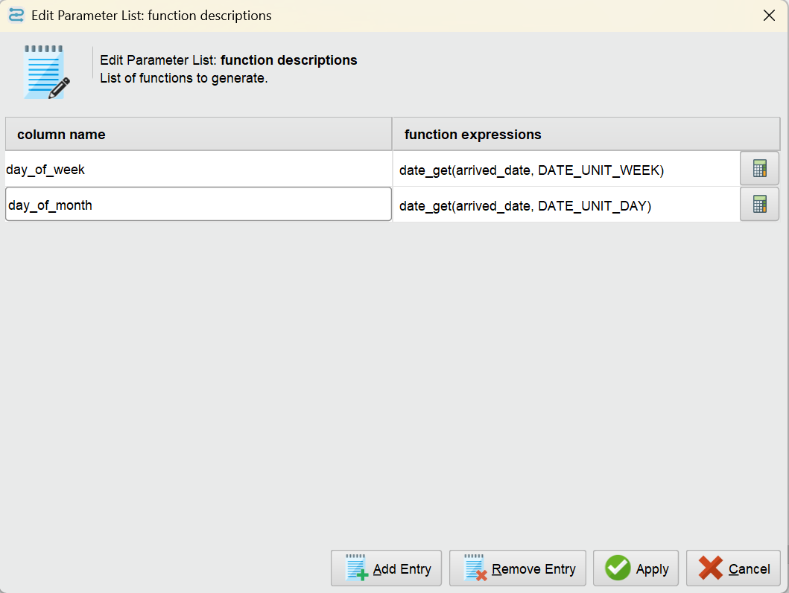
These features allow the model to understand weekly and monthly passenger trends.

STEP 6: SETTING THE TARGET VARIABLE
The target variable (label) was defined using the Set Role operator:
- total_on → set as label
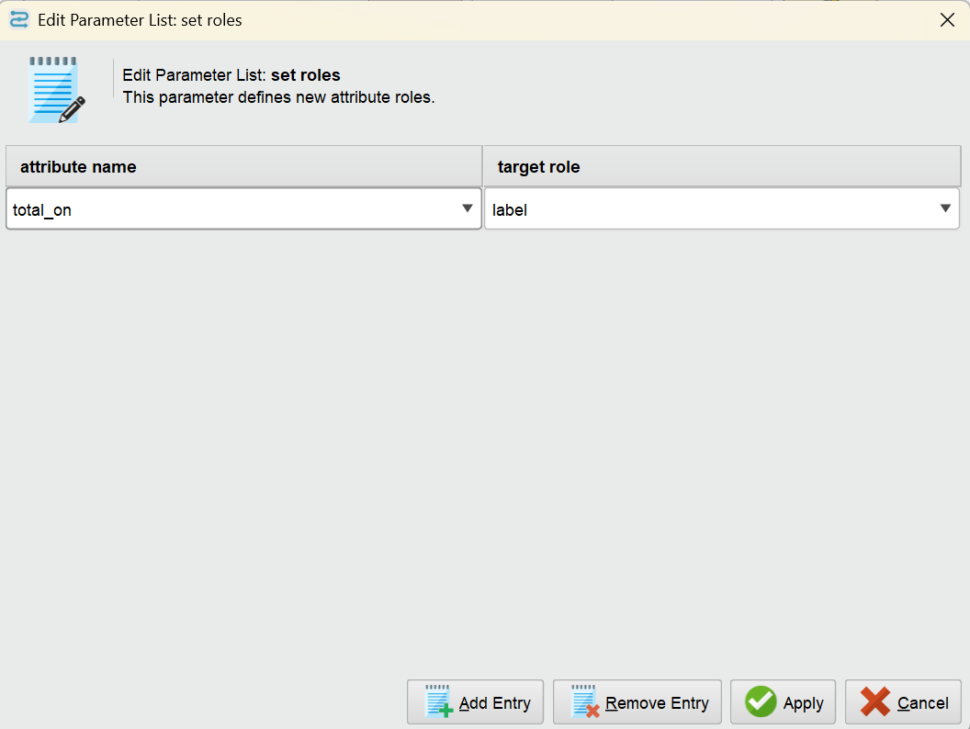
This tells the model what variable it needs to predict.
STEP 7: SPLITTING DATA
The dataset was split into training and testing sets using the Split Data operator:
- 80% → Training
- 20% → Testing
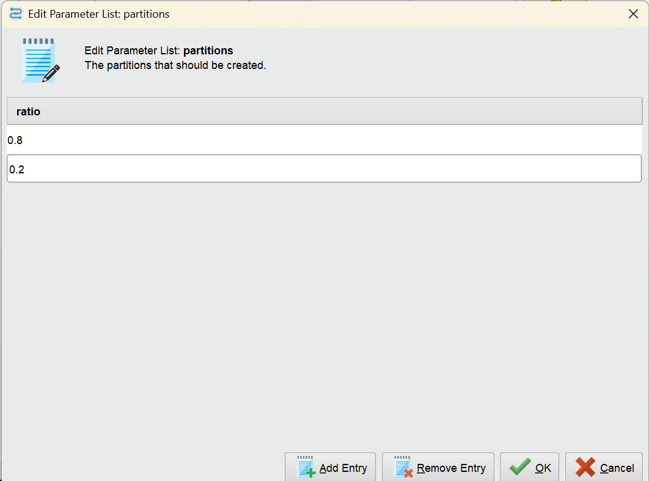
This allows the model to be evaluated on unseen data.

STEP 8: MODEL BUILDING (LINEAR REGRESSION)
A Linear Regression model was applied to the training data.
This model learns the relationship between:
- Input features: day_of_week, day_of_month
- Output variable: total_on

STEP 9: MODEL EVALUATION
The model was evaluated using the Performance (Regression) operator.
Results:
- RMSE: 17.937
- Correlation: 0.946
This indicates strong prediction performance.
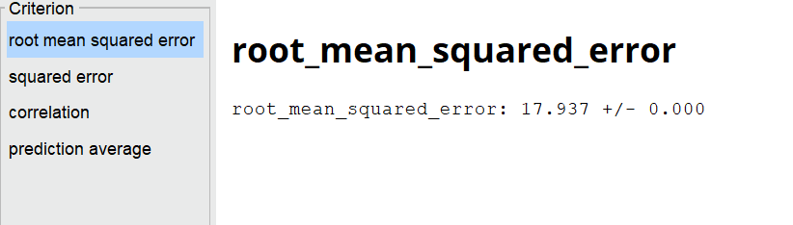
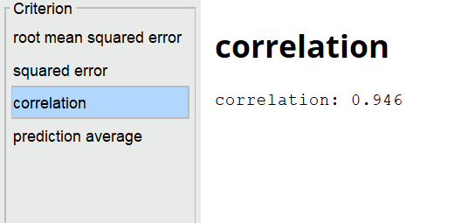

STEP 10: SAVING THE MODEL
The trained model was saved using the Store operator as:
- November_Model
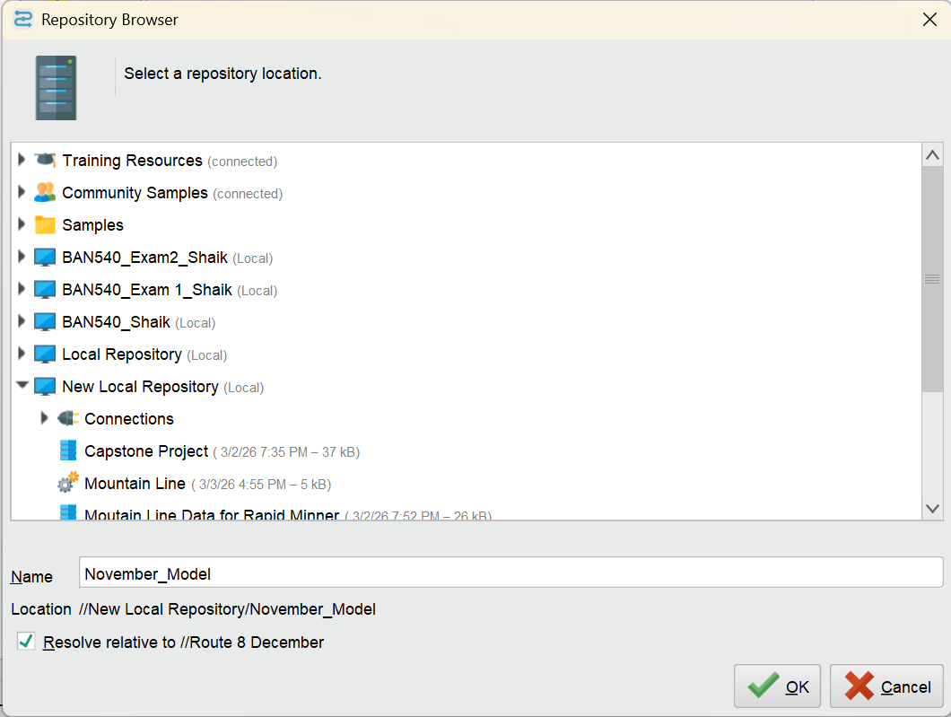
This allows reuse of the model for future predictions.
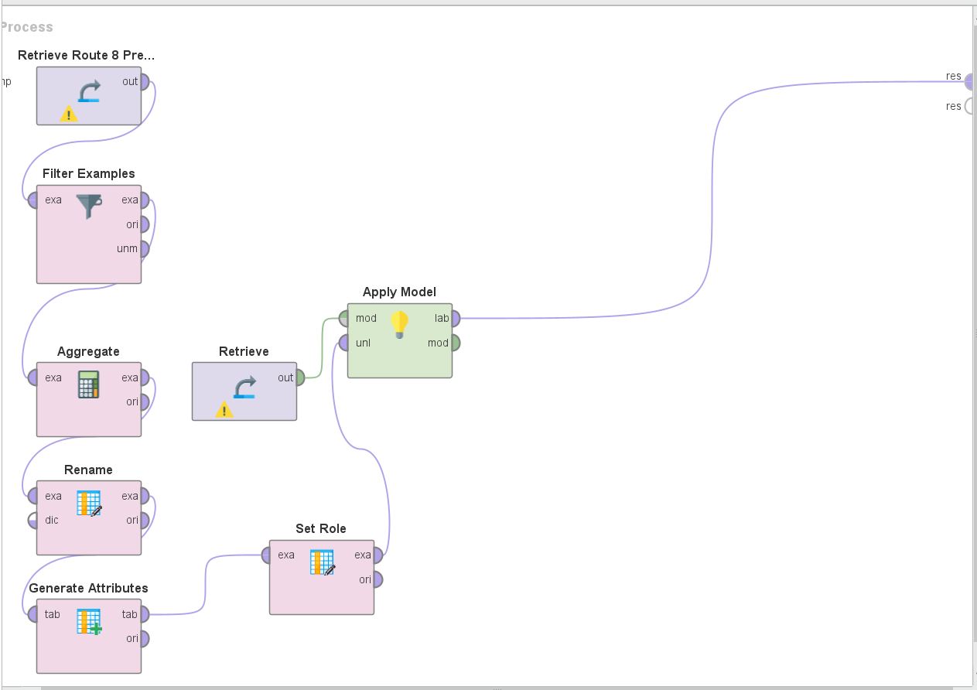
STEP 11: PREPARING DECEMBER DATA
A separate process was created to predict December values.
Using the Filter Examples operator, December data was selected:
- arrived_date ≥ 12/01/2025

- arrived_date ≤ 12/31/2025
Repeating same process by adding Aggregate, Rename, Generate Attributes

STEP 12: CONNECTING NOVEMBER RETRIEVE TO APPLY MODEL
The saved model was retrieved using the Retrieve operator and applied using the Apply Model operator.
This generated predicted passenger values for December.

STEP 13: RESULT ANALYSIS
The output shows:
- Actual passengers (total_on)
- Predicted passengers
The model predictions closely match actual values, demonstrating good performance.

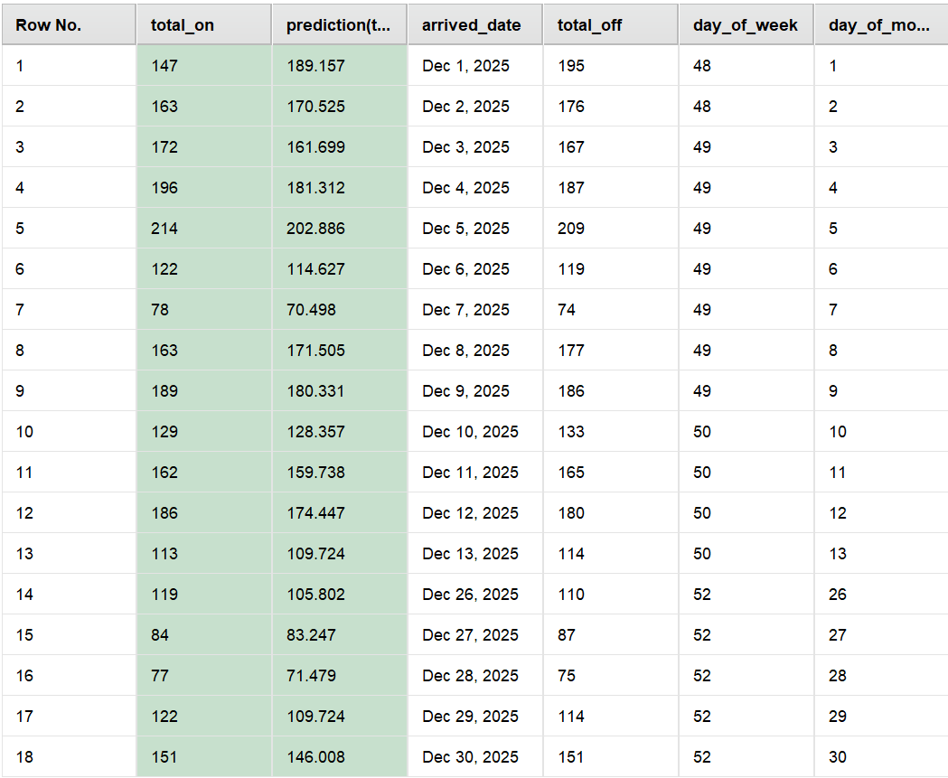

FINAL SUMMARY
The RapidMiner workflow successfully processed the raw dataset, transformed it into a structured format through aggregation and preprocessing, and created meaningful features such as day of the week and day of the month to capture temporal patterns in passenger behavior. Using these engineered features, a Linear Regression model was built and evaluated, achieving a Root Mean Squared Error (RMSE) of approximately 17.9 and a strong correlation of 0.946 between actual and predicted values. These results indicate that the model performs well in capturing overall passenger trends with a relatively low prediction error. The trained model was then applied to December data to generate future predictions, where the predicted values closely followed the actual passenger counts with only minor deviations on certain days. Additionally, the same prediction analysis was implemented using both Excel and Python to validate the results across different tools, ensuring consistency and reliability of the model. Overall, the model demonstrates good predictive performance and serves as a strong baseline for forecasting passenger demand, while also highlighting opportunities for further improvement by incorporating additional influencing factors.

